Test plan for
AmpedLearn

ChangeLog

Version | Change Date | By | Description
V1.0.1 | 28/09/2023 | Aniket, Amod | Improved Stability of the website while launching
V1.0.2 | 30/10/2023 | Himanshu | Debugged API launching

1 Introduction 2
1.1 Scope 2
1.1.1 In Scope 2
1.1.2 Out of Scope 2
1.2 Quality Objective 2
1.3 Roles and Responsibilities 2
2 Test Methodology 3
2.1 Overview 3
2.2 Test Levels 3
2.3 Bug Triage 3
2.4 Suspension Criteria and Resumption Requirements 3
2.5 Test Completeness 4
3 Test Deliverables 4
4 Resource & Environment Needs 4
4.1 Testing Tools 4
4.2 Test Environment 4
5 Terms/Acronyms 5

Introduction

- Project Focus: The project's primary goal is to assist students in selecting the most appropriate programming languages for their career aspirations. This involves analyzing industry trends, job demand, and language relevancy.

- Data Collection and Preprocessing: Data from various sources, such as GitHub events (issues, pull requests, stars), was collected and organized by year, language, and counts to facilitate time series analysis.

- Time Series Analysis: Auto-Regressive Integrated Moving Average (ARIMA) models were used for forecasting the popularity of programming languages in the future. Model selection and parameter tuning were carried out through statistical analysis.

- Model Evaluation: The chosen models were evaluated using Mean Absolute Error (MAE) and Mean Absolute Percentage Error (MAPE) to ensure the most accurate predictions of language popularity trends.

- Visualization: Visualizations were created to present forecasted language popularity trends in a user-friendly manner, offering students insights into expected language trends.

- Technology Stack: The project employed a combination of frontend (HTML, CSS, React) and backend (Express, Node.js, MongoDB) technologies, facilitating a user-friendly platform and database for student information and progress.

- Machine Learning: Machine learning techniques were integrated to perform real-time language usage analysis, which involved tracking language growth rates, industry requirements, and salary trends.

- Scalability and Future Enhancements: Future plans include enhancing the user interface, providing certifications, practice sets, premium memberships, and live sessions, indicating a clear workflow for ongoing development and improvement.

Scope

In Scope

Functional Requirements:
- Language Comparison: The software will provide a feature for students to compare different programming languages based on factors such as industry demand, job opportunities, and relevance. This feature will help students make informed decisions about which languages to learn.
- Resource Recommendations: The platform will recommend resources and learning materials from various platforms to help students improve their proficiency in the selected language. This may include online courses, tutorials, and books.
- Roadmaps: Students will have access to roadmaps that outline a structured learning path for each language. These roadmaps will guide students in mastering fundamental concepts and progressing through advanced topics in a logical order.
- Community Engagement: The software will facilitate community engagement by allowing students to share their own experiences, insights, and guidance with others. It will encourage collaboration and mutual assistance among learners.

Non-Functional Requirements:
- User Interface (UI): The platform will prioritize an intuitive and user-friendly interface, making it easy for students to navigate, access information, and make decisions.
- Scalability: The software should be designed to handle increasing user loads and data as more students use the platform. It should scale smoothly as the user base grows.
- Data Security: Protecting student data is crucial. The platform should implement strong security measures to safeguard personal information and progress records.
- Performance: The software should provide a responsive and high-performance experience, ensuring quick access to data, resources, and recommendations.
- Real-time Data Analysis: For features related to language trends, the software should deliver real-time data analysis to give students the most up-to-date information.

Out of Scope
Out of Scope Features:
- Advanced Language-Specific IDEs: Developing advanced Integrated Development Environments (IDEs) for specific programming languages is out of scope. Your project focuses on language selection, resources, and guidance rather than building code editors.
- Content Creation: Creating original learning content, such as tutorials, courses, or books, is not part of the project's scope. Your platform recommends existing resources from other sources.
- Social Networking Features: Complex social networking features like chat, social feeds, or forums are not within the project's scope. While community engagement is encouraged, extensive social networking features are out of scope.
Out of Scope Functional Requirements:
- E-commerce Functionality: The project doesn't include e-commerce features for buying or selling products. It focuses on educational content and guidance, not commercial transactions.
- Learning Management System (LMS) Capabilities: Extensive LMS features, such as grading, course management, or student administration, are not part of the scope. Your project primarily focuses on language recommendations and resources.
- Custom Learning Paths: Highly customized, individualized learning paths for each student are out of scope. The project provides predefined roadmaps for languages.
Out of Scope Non-Functional Requirements:
- Regulatory Compliance: Meeting specific industry or government regulations, such as data privacy laws or accessibility requirements, may be out of scope. Your project should comply with relevant regulations, but compliance details are not within the scope.

Quality Objective

- Conformance to Functional and Non-Functional Requirements: The primary objective of testing is to ensure that the Application Under Test (AUT) aligns with both functional and non-functional requirements. This involves verifying that the platform's features, such as language comparison, resource recommendations, roadmaps, and community engagement, work as intended. It also includes confirming that non-functional requirements, like performance, security, and scalability, are met.
- Quality Assurance: Testing aims to assure the quality of the platform by verifying that it meets the quality specifications defined by the client. This involves evaluating the overall user experience, including usability, responsiveness, and reliability. It also includes ensuring that the platform's content recommendations and language trend predictions are accurate and reliable.
- Bug and Issue Identification: One of the primary objectives of testing is to identify and document bugs, issues, or defects within the platform. These issues could include functionality errors, inconsistencies, or unexpected behaviors. Identifying these problems early in the development process allows for their resolution before the platform goes live.
- Data Accuracy: Given the importance of language trend predictions and recommendations in your project, testing should specifically aim to validate the accuracy of data and forecasts. The platform's language popularity predictions and recommendations must be reliable and up-to-date to benefit students.

Roles and Responsibilities
Aniket Bhardwaj: He developed a robust forecasting algorithm that predicts the popularity of programming languages, aiding users in making informed decisions.

Amod Katiyar: His contribution involved creating the frontend algorithm, facilitating users in accessing language-specific learning resources effortlessly.

Himanshu Kumar: He conducted rigorous testing procedures and authored vital written material, including patent drafts and the research paper, contributing to the project's quality and documentation.

Test Methodology

Overview

An Agile methodology is the most suitable for my project. It allows for flexibility, ongoing testing, and adaptation, which are essential for projects that involve machine learning, image processing, and AI. Agile enables you to respond to changing requirements and refine the style transfer algorithm as you gain insights from testing and user feedback.

Test Levels

The testing to be performed is white box testing.
The testing is performed by the developer’s team along with QA and Configuration Manager.

Test Completeness
Here you define the criterias that will deem your testing complete.
For instance, a few criteria to check Test Completeness would be
- 100% test coverage
- All Manual & Automated Test cases executed
- All open bugs are fixed or will be fixed in next release
- All content and style transfer tests have been executed, ensuring that various input images have been processed successfully and meet the defined content and style transfer criteria.
- Automated regression tests have been executed, and previously tested features still work as expected after updates or changes

Test Deliverables

Test cases:-

Test Case | Test Objective | Test Data | Expected Result |  | Actual Result | Pass/Fail
1 | User Login | User Id and Password | Only Valid User login in the system |  | Unauthorized  User can  not login | Pass
1 | Model Training | Training data with content | Model converges, successfully learns |  | Model successfully learns | Pass
2 | Content Preservation | Generated Value | Content remains recognizable |  | Content recognizable | Pass
3 | Verify data security | Testing with simulated security breaches | No unauthorized access or data breaches detected |  | Unauthorized  User can  not access | Pass
4 | Assess the impact of updates | System before and after updates | Previously tested features still work as expected |  | Previously tested features work accurately | Pass

Decision Table for User Login

Conditions | Rule 1 | Rule 2 | Rule 3 | Rule 4
Username | False | True | False | True
Password | False | False | True | True
Output(e/h) | error | error | error | homepage

Test case Output Images:-

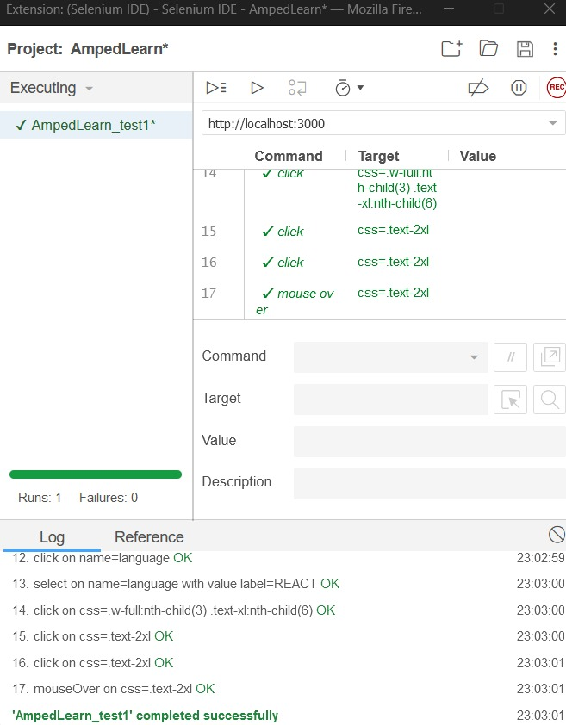

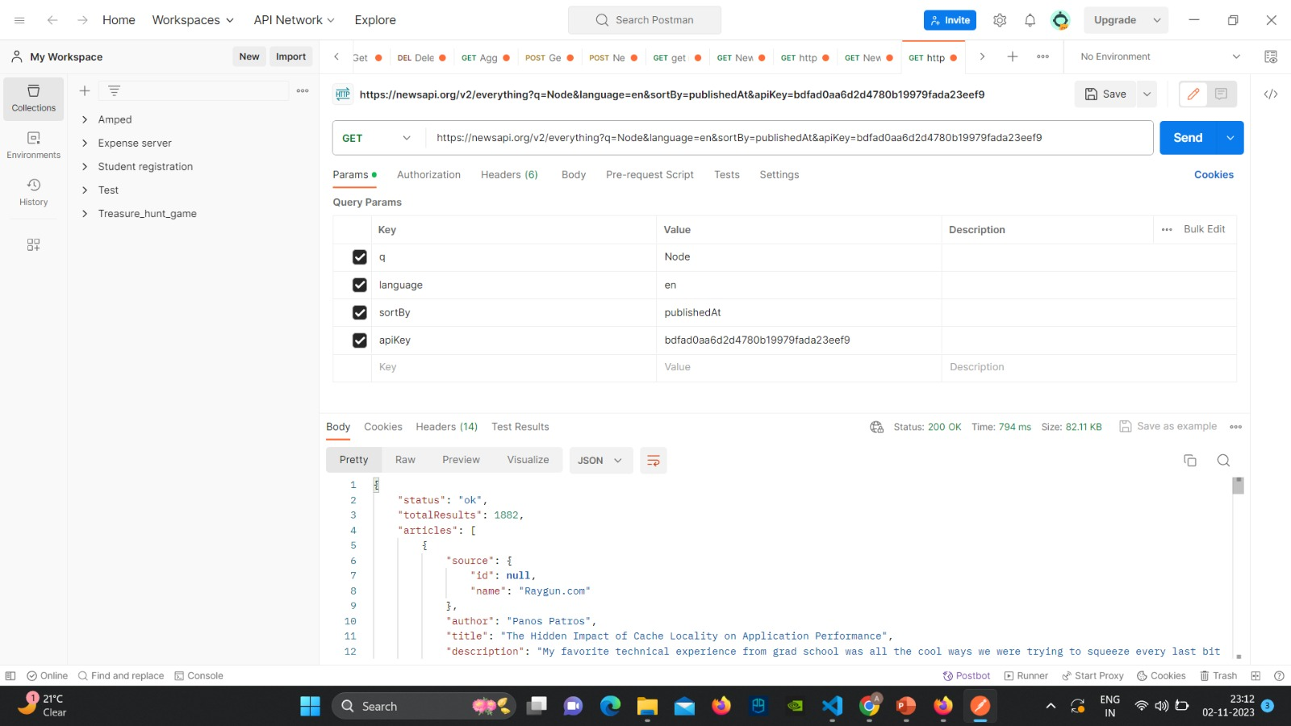

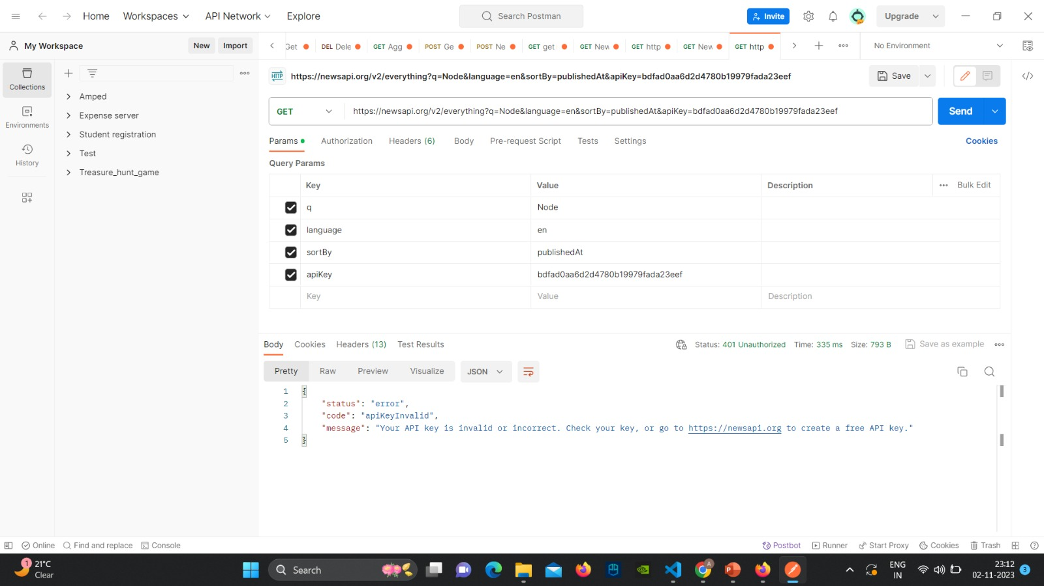
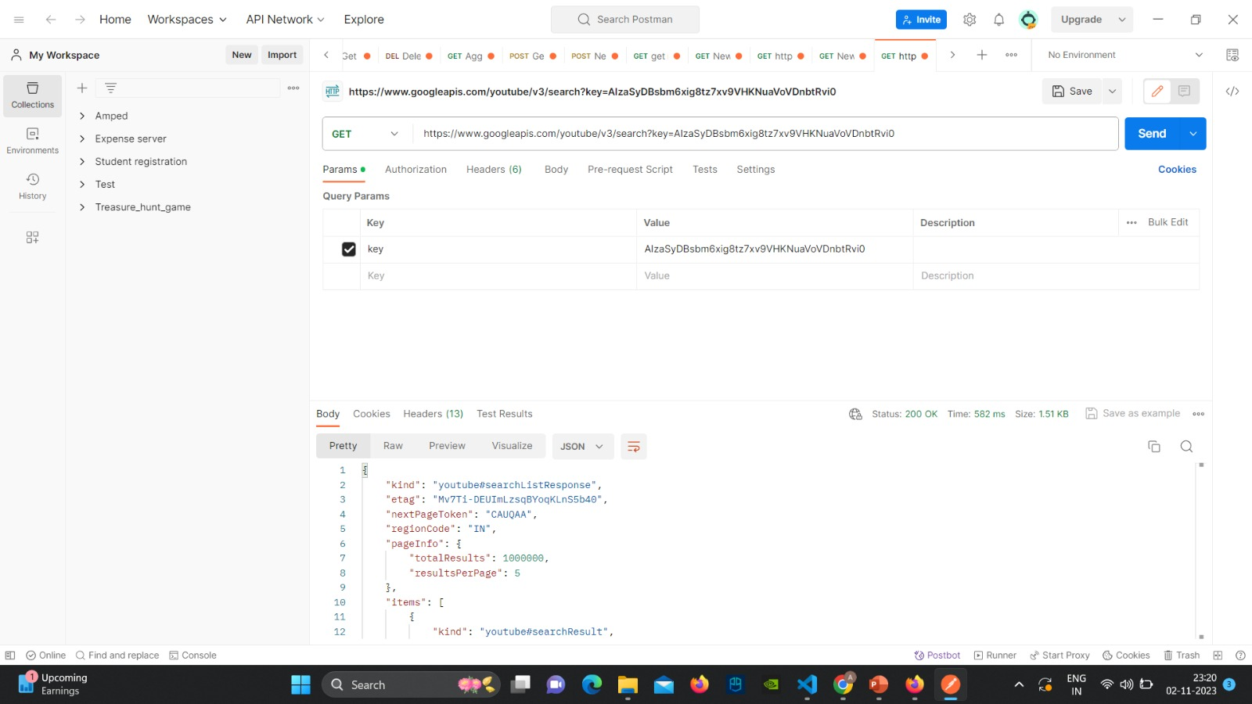
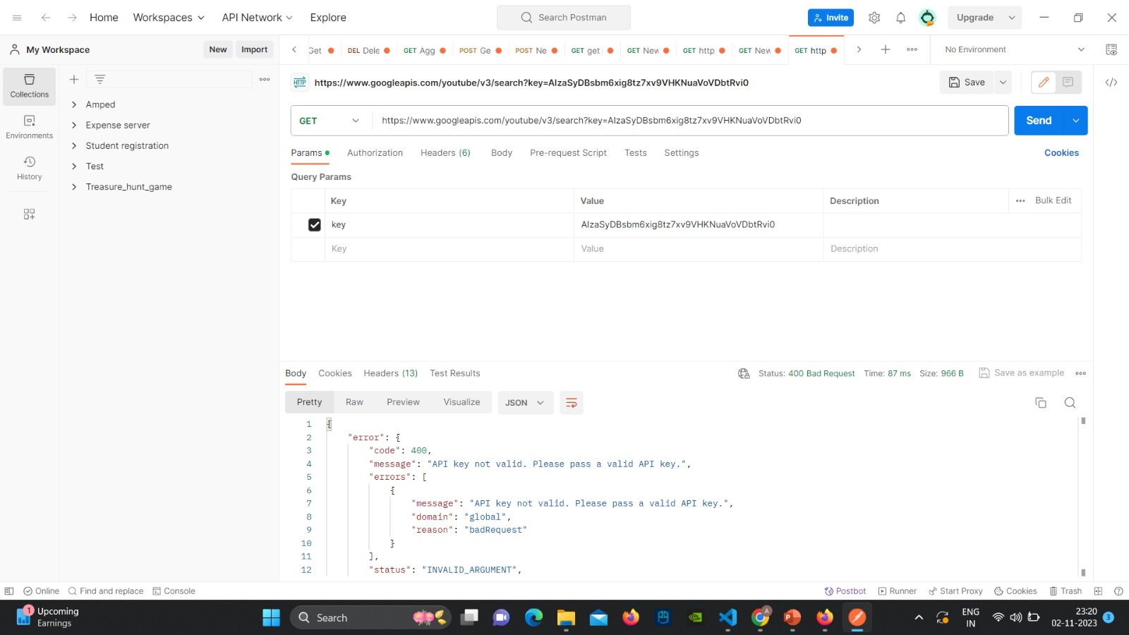

Resource & Environment Needs

Testing Tools

Requirements Tracking Tool:
- JIRA: JIRA is a versatile tool for tracking requirements, user stories, and project tasks. It can help manage and prioritize project requirements effectively.

Bug Tracking Tool:
- Mantis: Mantis is used for tracking and managing software defects, making it an essential tool to ensure all identified issues and bugs are documented, monitored, and resolved efficiently.
Automation Tools:
- Selenium: Selenium is a widely used automation tool for testing web applications. In your project, Selenium can automate the testing of various functionalities on the language selection and learning guidance platform, helping ensure functionality and user interface consistency.

Test Environment
- Modern operating system (e.g., Windows 10, macOS, or Linux).
- Common web browsers (e.g., Chrome, Firefox, Edge).
- Testing tools (Mantis for bug tracking, Selenium for automation).
- Additional software like an integrated development environment (IDE) and virtualization tools if needed.

Terms/Acronyms
Make a mention of any terms or acronyms used in the project

TERM/ACRONYM | DEFINITION
AUT | Application Under Test. Refers to the software or application being tested, such as the language selection and learning guidance platform in your project.
NLP | Natural Language Processing. A technology used for text analysis and data extraction to understand and predict language trends.

API | Application Programming Interface. Used to extract data from various web sources and integrate it into your platform.
ARIMA | Auto-Regressive Integrated Moving Average. A statistical model used for time series analysis, employed for forecasting language popularity trends.
MAE | Mean Absolute Error. An evaluation metric used in the fine-tuning of ARIMA models to determine model accuracy.
MAPE | Mean Absolute Percentage Error. Similar to MAE, MAPE is used for evaluating the accuracy of ARIMA models.

